**MAT-248**

Applied Linear Algebra

Group Members :

1. Neel Sheth - AU2140005

2. Keval Juthani - AU2140028

3. Adnan Kadiwala - AU2140001

4. Malhar Patel - AU2140226

5. Krishna Patel - AU2140170

Group Number : 23

---------------------------------------------------------------------------------------------

A. Inverse of a Matrix:

Test Case Link :

1) 5*5

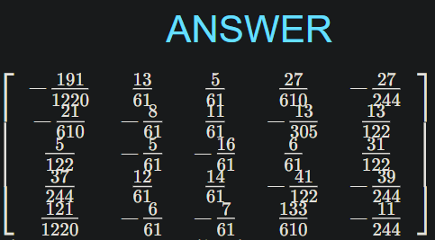

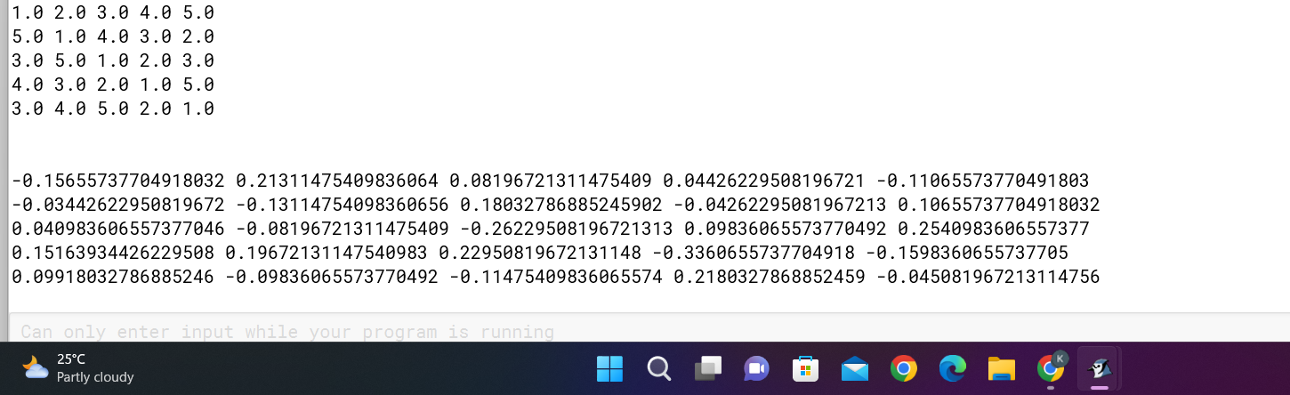

<https://www.emathhelp.net/calculators/linear-algebra/inverse-of-matrix-calculator/?i=%5B%5B1%2C2%2C3%2C4%2C5%5D%2C%5B5%2C1%2C4%2C3%2C2%5D%2C%5B3%2C5%2C1%2C2%2C3%5D%2C%5B4%2C3%2C2%2C1%2C5%5D%2C%5B3%2C4%2C5%2C2%2C1%5D%5D&m=g>

2) 4*4

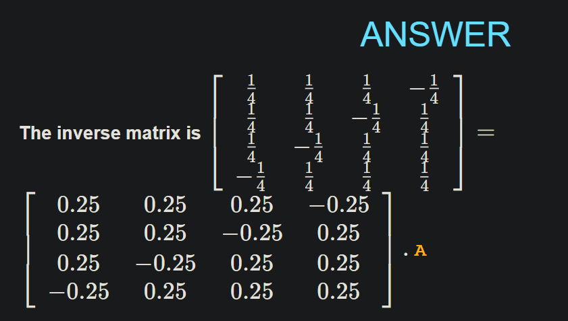

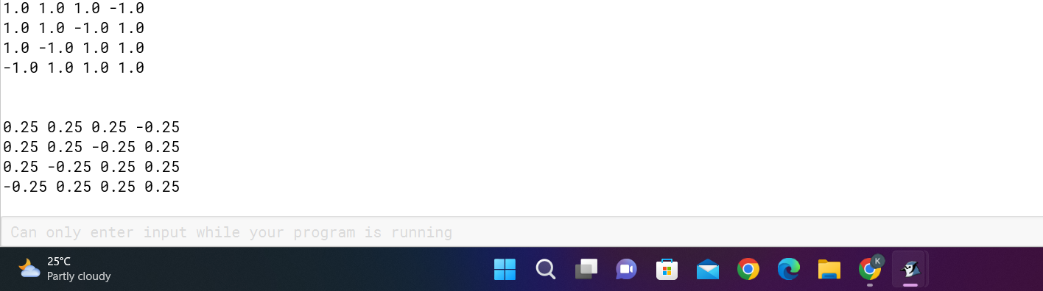

<https://www.emathhelp.net/calculators/linear-algebra/inverse-of-matrix-calculator/?i=%5B%5B1%2C1%2C1%2C-1%5D%2C%5B1%2C1%2C-1%2C1%5D%2C%5B1%2C-1%2C1%2C1%5D%2C%5B-1%2C1%2C1%2C1%5D%5D&m=g>

B. Multiplication of a Matrix:

Test Case Link:

1) (4*4) x (4*4)

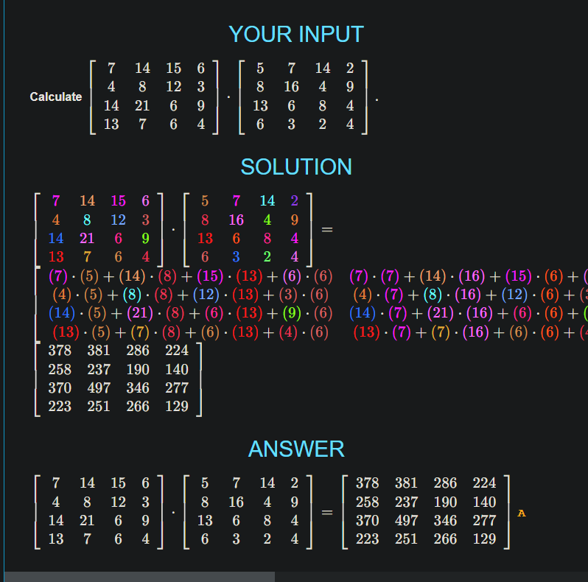

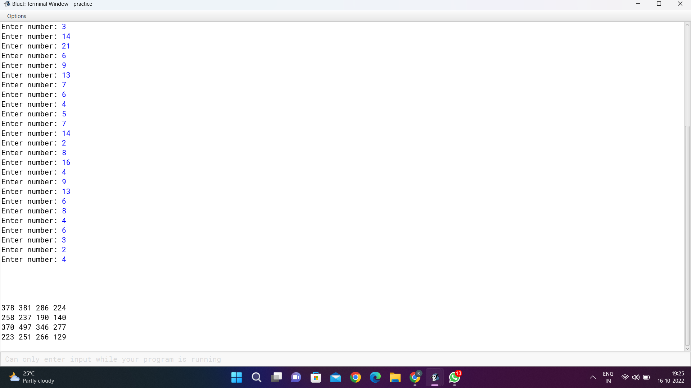

<https://www.emathhelp.net/calculators/linear-algebra/matrix-multiplication-calculator/?a=%5B%5B7%2C14%2C15%2C6%5D%2C%5B4%2C8%2C12%2C3%5D%2C%5B14%2C21%2C6%2C9%5D%2C%5B13%2C7%2C6%2C4%5D%5D&b=%5B%5B5%2C7%2C14%2C2%5D%2C%5B8%2C16%2C4%2C9%5D%2C%5B13%2C6%2C8%2C4%5D%2C%5B6%2C3%2C2%2C4%5D%5D>

2) (3*4) * (4*3)

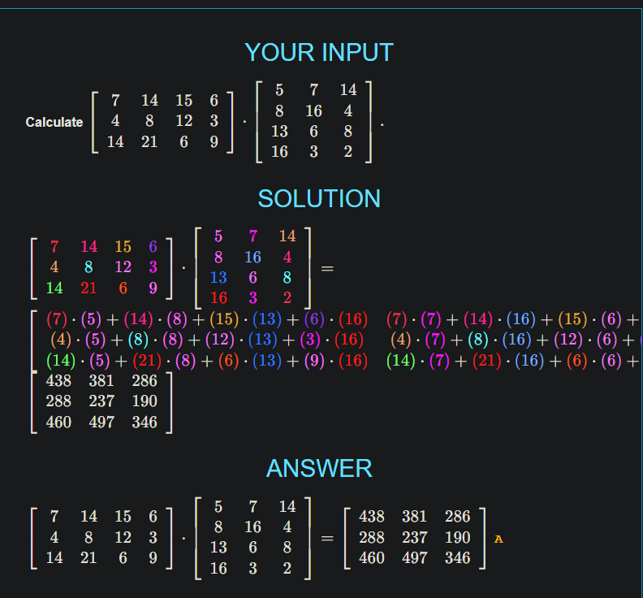

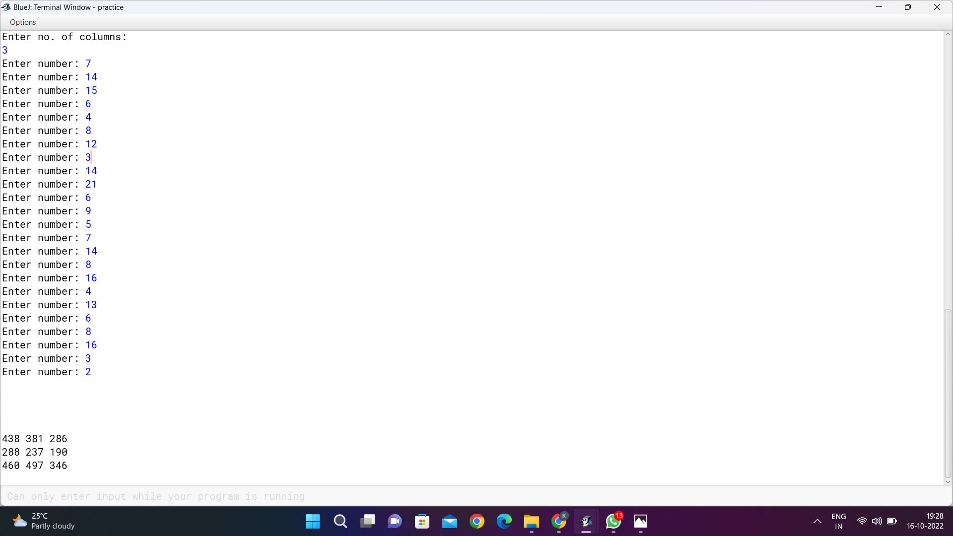

<https://www.emathhelp.net/calculators/linear-algebra/matrix-multiplication-calculator/?a=%5B%5B7%2C14%2C15%2C6%5D%2C%5B4%2C8%2C12%2C3%5D%2C%5B14%2C21%2C6%2C9%5D%5D&b=%5B%5B5%2C7%2C14%5D%2C%5B8%2C16%2C4%5D%2C%5B13%2C6%2C8%5D%2C%5B6%2C3%2C2%5D%5D>

C. System of Linear Equations:

Test Case Link:

1) (3*4)

<https://chbe241.github.io/Module-0-Introduction/MATH-152/Unique%20Solution,%20No%20Solution,%20or%20Infinite%20Solutions.html>

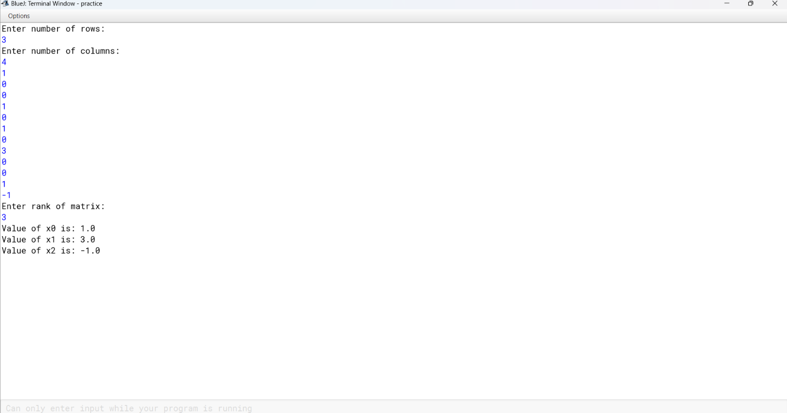

2) (3*4)

<https://chbe241.github.io/Module-0-Introduction/MATH-152/Unique%20Solution,%20No%20Solution,%20or%20Infinite%20Solutions.html>

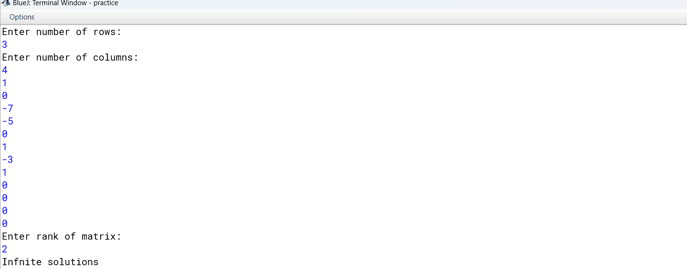

3) (3*4)

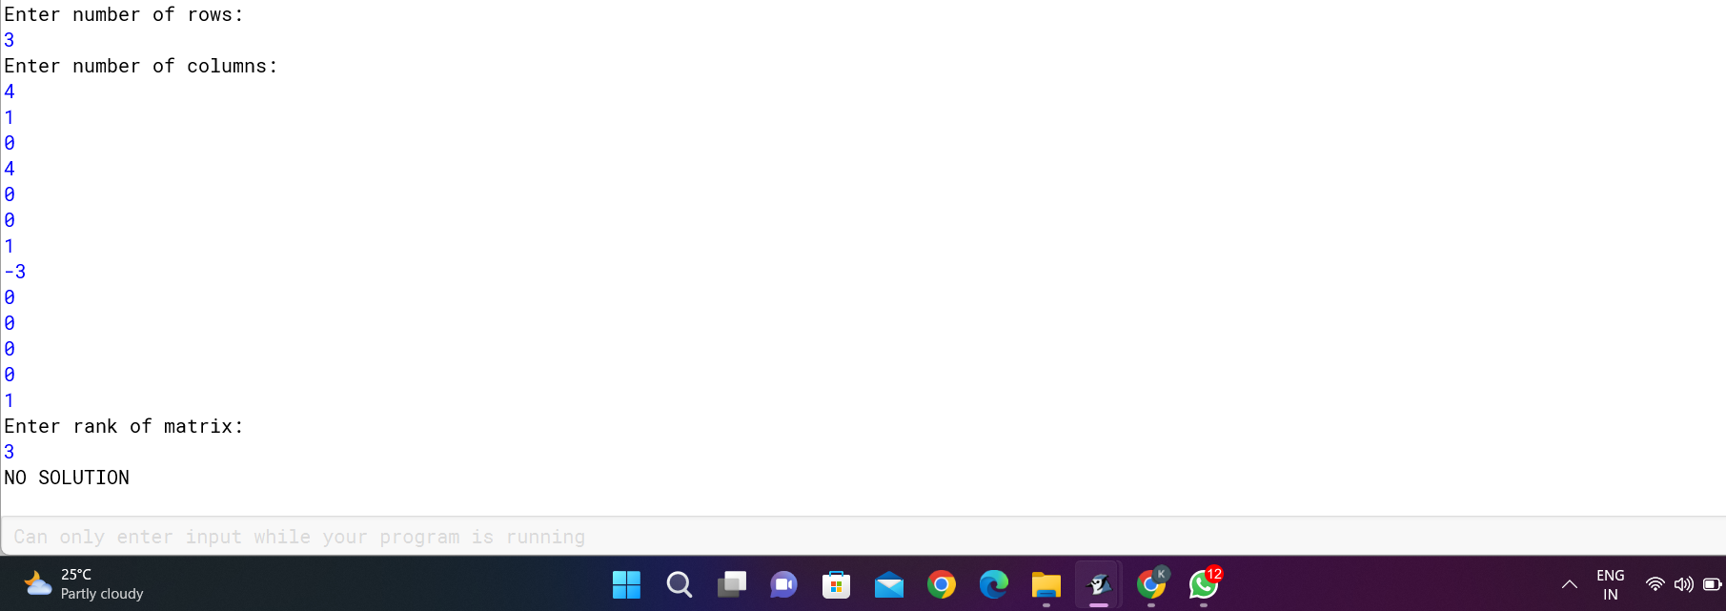

D. Vector Representation:

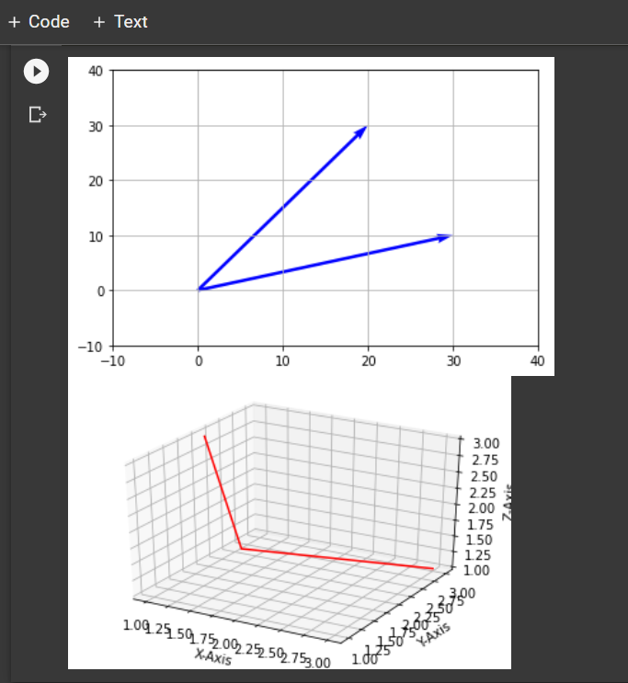

Colab Link:

<https://colab.research.google.com/drive/1Pw39Sngpj4FO7kOZ1Q92K1uNJYhc9BdD>

E. Norm of Matrix:

1. 3*4

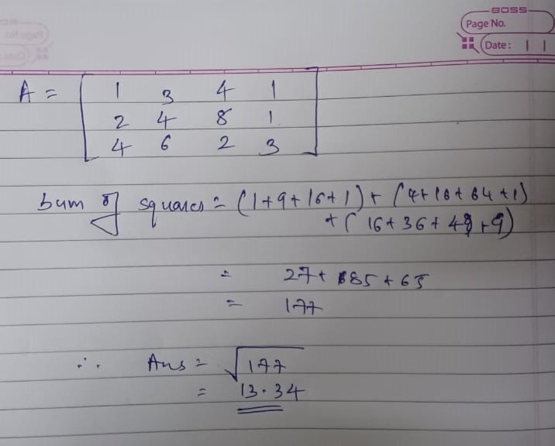

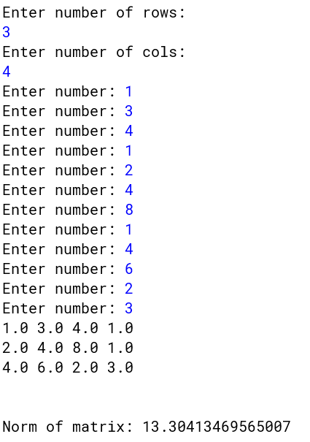

1. 4*4

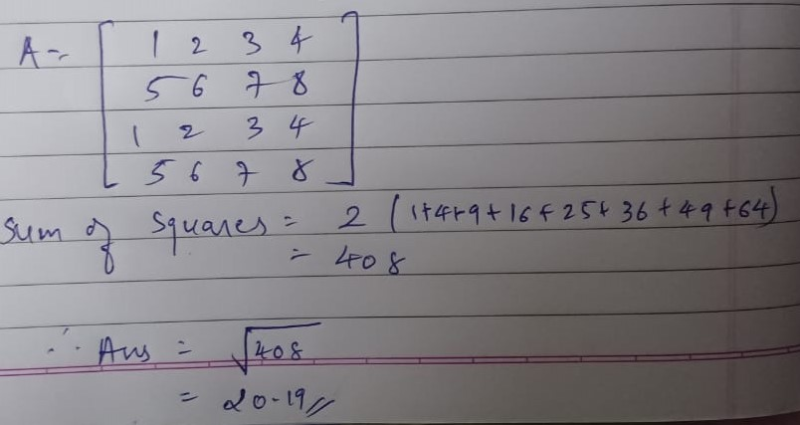

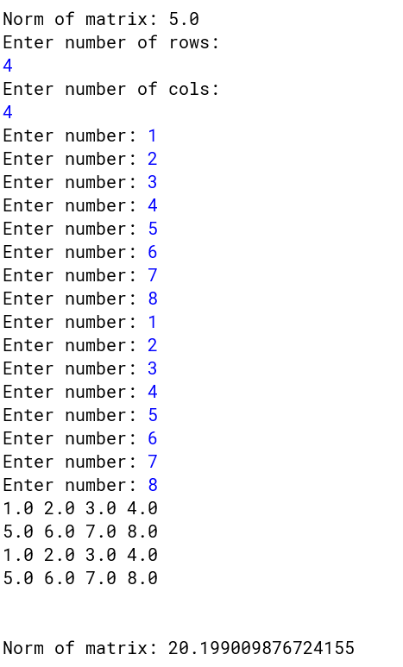

F. Row reduction Of Matrix:

Test Case Link:

1) 4*4

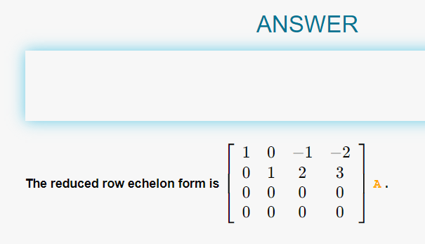

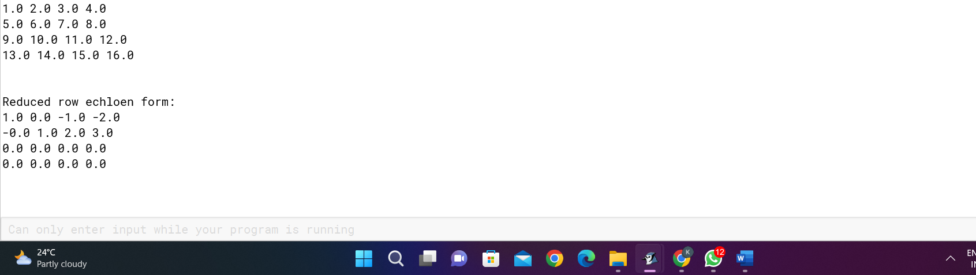

<https://www.emathhelp.net/calculators/linear-algebra/reduced-row-echelon-form-rref-calculator/?i=%5B%5B1%2C2%2C3%2C4%5D%2C%5B5%2C6%2C7%2C8%5D%2C%5B9%2C10%2C11%2C12%5D%2C%5B13%2C14%2C15%2C16%5D%5D&reduced=on>

2)5*5

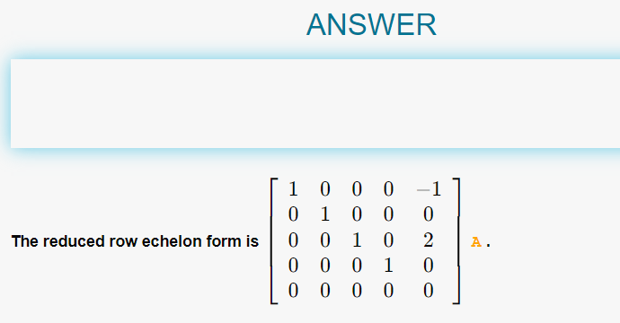

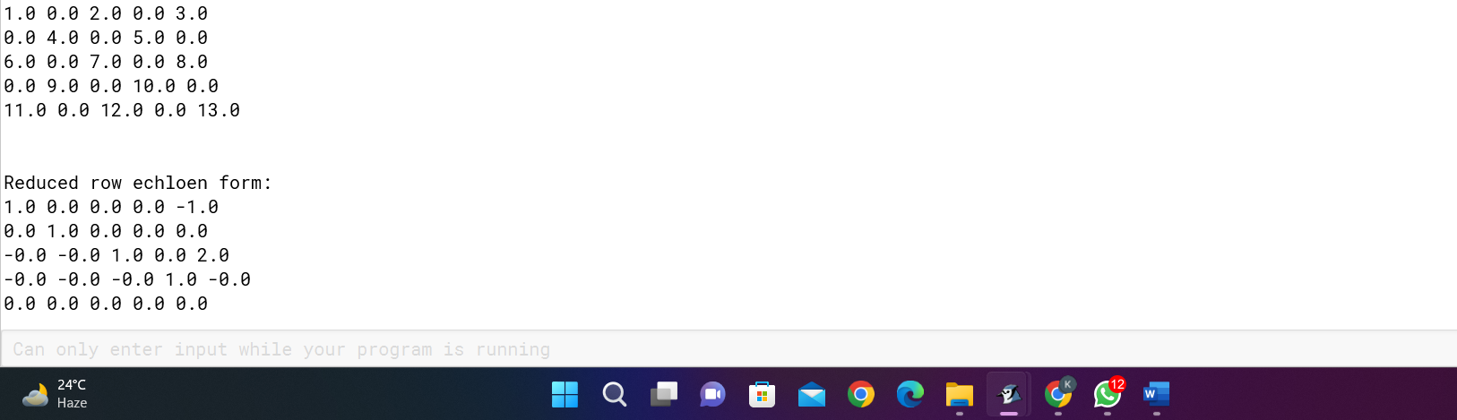

<https://www.emathhelp.net/calculators/linear-algebra/reduced-row-echelon-form-rref-calculator/?i=%5B%5B1%2C0%2C2%2C0%2C3%5D%2C%5B0%2C4%2C0%2C5%2C0%5D%2C%5B6%2C0%2C7%2C0%2C8%5D%2C%5B0%2C9%2C0%2C10%2C0%5D%2C%5B11%2C0%2C12%2C0%2C13%5D%5D&reduced=on>

G. Rank of Matrix:

1. 4*4

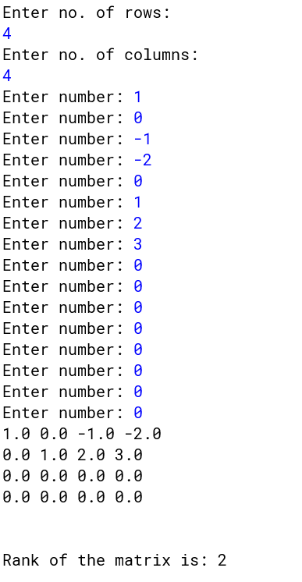

1. 5*5

